**JPEG IMAGE COMPRESSION USING MATLAB**

# A Project Report

# *SUBMITTED BY*

Akashdeep Mohanty - 2330360

Navya Pathak - 2330380

Riddhi Khanna - 2330393

Sumita Saha - 2330413

**1. AIM :** JPEG Image compression using MATLAB.

**2.SOFTWARE REQUIRED : MATLAB**

1. **THEORY :**

**a)INTRODUCTION:** An image is a rectangular array of dots, called pixels. The size of the image is the number of pixels.The Multimedia images plays a crucial role in storing the moments and memories of day to day life.We can easily transmit multimedia information through web network. Now a days, use of camera, transformation and manipulation of images is grown explosively. These digital picture files are huge in size and take large part of memory. While transmitting and receiving signal they waste enormous bandwidth which is a main constraint for us. For eg: an1image consists of 256X256pixels and it stores 65,536 elements, while downloading of such types of files from internet takes lot of time. For the efficient utilization of the memory, bandwidth and time, we have come up with the solution i.e. JPEG image compression. Image compression is a technique which compresses all the digital images so that they cover less space. With the use of image compression system, efficiency and speed increases whereas processing time, memory storage and capacity decreases.

The JPEG(Joint Photographic Experts Group) is first introduced in 1992, since introduction, it is most widely used image compression standard in the world. JPEG is also termed as JPG, which is a commonly used method of lossy and lossless compression for digital images. For this JPEG images, the degree of compression can be adjusted by using a selectable trade-off in between the storage size and the image quality. The process begins by converting images from RGB (Red, Green, Blue) to YCbCr, separating brightness from color, as our eyes are more sensitive to light than to color detail. Next, subsampling reduces the resolution of the color channels. The core of JPEG compression involves the Discrete Cosine Transform (DCT), where images are split into 8x8 pixel blocks, transforming the data into frequency components. After that, quantization reduces the precision of these components based on a quantization matrix, discarding less important information to minimize file size. Finally, entropy coding techniques like Huffman coding further compress the data by eliminating redundancies. . The JPEG compression algorithm is mostly done on photographs and paintings with small variations in tone and colour.JPEG file format enables the bitstreams to be exchanged between a large variety of platforms and applications.

**b) BANDWIDTH AND TRANSMISSION :**

In our high stress, high productivity society, efficiency is key. Most people do not have the time or patience to wait for extended periods of time while an image is downloaded or retrieved. In fact, it has been shown that the average person will only wait 20 seconds for an image to appear on a web page. .Without some type of compression images would be too cumbersome and impractical for use. The following table is used to show the correlation between modem speeds and download time.

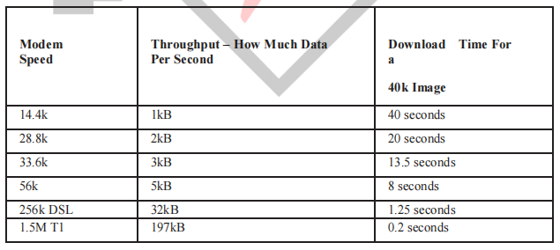

**FIG : Download Time Compression**

**c) IMAGE COMPRESSION :**The images are generally compressed to decrease the space required to store the images without changing the information present in the images. The compressed image will be of a lower quality with respect to the original image and is easy to transmit or download.

**Lossless Compression:**

It is a data compression that uses an algorithm which converts the data from a compressed image into original image. Lossless compression does not eliminate the data which is not noticeable. The file format can be restored in its original form. The compression does not compromise the data quality. This compression holds less data capacity compared to lossy compression. It is also termed as reversible compression.

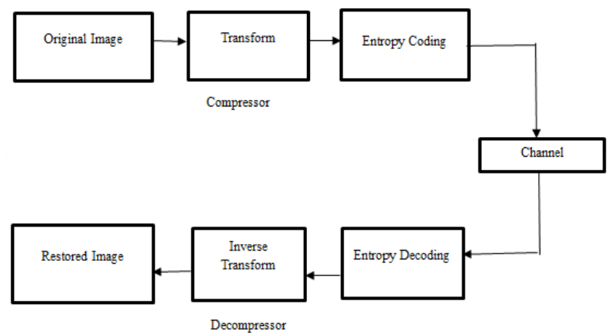

**FIG :Block diagram of Lossless compression method.**

**Lossy Compression:**

The Lossy compression is a data compression of the size of the file is reduced by removing the data in the file. While compression makes the image quality to be decrease file size. It eliminates the data which is not considered. While compression the file does not rebuild in its original form. It is used in Images, Audio, Video. It is also termed as irreversible compression.

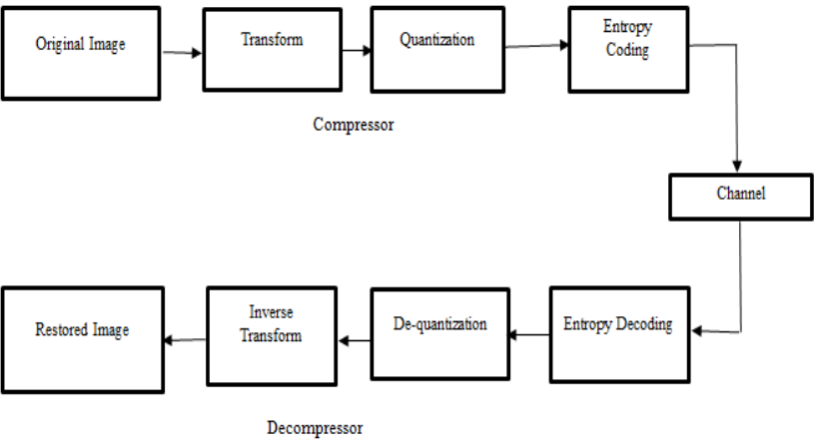

**FIG : Block diagram of Lossy compression method**

Image-compression is1a1method1which lessens the measure of information required to speak to an advanced image. This can be accomplished by expelling the redundancies

• Spatial Redundancy

• Spectral redundancy

• Psycho-visual redundancy

**1.Spatial redundancy:** The redundancy in which there is a correlation between the neighbouring pixel values is known as spatial redundancy

**2.Spectral redundancy:** The correlation between different spectral bands and different colour planes is known to be spectral redundancy.

**3.Psycho-visual redundancy:** The tendency of which the unimportant information of the human visual system is removed is known as psychovisual redundancy.

**d) DISCREATE COSINE TRANSFORM:** Discrete Cosine Transform is an algorithm which is used to develop fast Fourier transform. It is first introduced in 1972 by Nasir Ahmed. It is used mostly in digital processing that makes us to find the patterns and to implement the Wiener filtering. It is as similar as Discrete Fourier transform which transforms the image from spatial domain to frequency domain. It does not reduce the number of bits required for the block. The DCT can be considered as ratio of the performance versus computational cost that has been adopted for international standards. It has areal transform with great advantages in energy compaction. When we compare the speed implementations the DCT is fast than DFT. Due to cosine basis functions the DCT is a shift variant, with one important exception.DCT expresses a finite sequence of the data points in terms of a sum of cosine functions oscillating at the different frequencies. It is widely used for digital media in which are known to be digital audio and videos, radios, and speech coding’s.

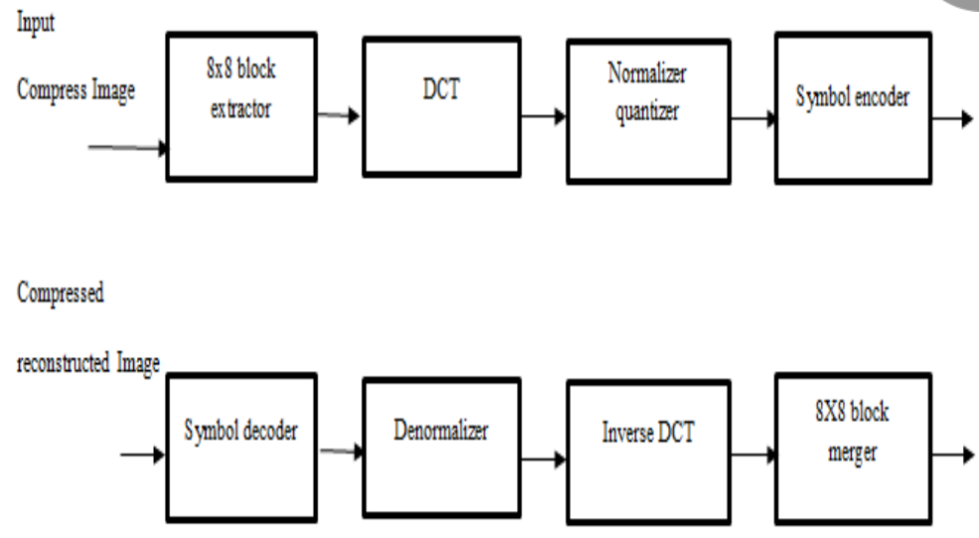

**FIG : DCT formed by Image compression**

**e)Discrete Wavelet Transform (DWT)**: In this sort of system technique, picture is taken as as a total of wavelet capacities/functions, known as wavelets, with various area and scale. The picture produces the information into an arrangement of detail and surmised coefficients. Right of the bat, the picture is separated into squares of 32×32. Each piece or block is then gone through the filters : the principle undertaking of first filter is to decmpress the information into an estimated and detailed coefficients. In the wake of getting the new transforming matrix, the detail and comparative coefficients which are isolated as ‘LL’, ‘HL’, ‘LH’, and ‘HH’ ‘coefficients’. Every one of the coefficients are disposed of aside from the ‘LL coefficients’ that are changed into the second level. The coefficients are then gone through a steady scaling component to accomplish the coveted ‘compression ratio’.

**f) JPEG process:**

The first step in image compression is that to break the image into 8^8 blocks.

While the breaking is done, we must apply the DCT to each image.

Therefore, by quantization each block is get compressed.

While the breaking is done, we must apply the DCT to each image. Therefore, by quantization each block is get compressed.

The Compression of the Image starts with converting the original image which is in RGB colours into YIQ or YUV. The letter Y in YIQ shows the brightness and IQ represents the chromeness. In YUV, Y represents the brightness and UV represent the colour of the image. The colour transformed image is involved in sampling in 8x8 block extractor. Image formed after sampling contains values f (u, v) where u and v represent different blocks of the image. The values are now passed through the Discrete Courier Transform as the next step. The unwanted values are removed then quantization process reduces the size and quality. In encoding process zero and non-zero values are aligned in zig zag form for representing the f (u, v) values as dc1 and ac1 respectively. The values that are lost during the entire process results in the compressed image. The Discrete Cosine Transform which is just like Discrete Fourier Transform is implemented by using only real numbers. .The DCT is mostly related to Fourier series coefficients of symmetrically and periodically sequence. There are eight standard DCT variants in which the most used is the type- II DCT. The DCT is also called Block compression, which compresses the data to discreate DCT blocks. The DCT blocks have several sizes, with 8x8 pixels for standard DCT and 4x4 and 32x32 pixels for varied DCT. The DCT has a strong energy compaction property, which can achieve high quality at high data compression ratios. The blocky compression artifacts can appear when heavy DCT compression is applied. The DCT is widely used in many applications. The end result is a compressed JPEG image that retains visual fidelty while significantly reducing file size, and this entire process can be implemented effectively in MATLAB .

**g) Advantages of JPEG image compression**:

1. File Size Reduction: JPEG significantly reduces the file size of images, making them easier to store and share.

2. Quality Preservation: It maintains a good level of visual quality, especially for photographs, even after compression.

3. Wide Compatibility: JPEG is a universally accepted format, compatible with almost all devices and software.

**h) Disadvantages of JPEG image compression:**

1. Lossy Compression: JPEG compression is lossy, meaning some image data is permanently lost, which can affect quality, especially at high compression levels.

2. Artifacts: High compression can introduce visible artifacts, such as blurring or blockiness, especially in areas with sharp edges or fine details.

3. Limited Editing Flexibility: Once an image is compressed, further editing can degrade the quality more significantly compared to lossless formats.

**h) APPLICATIONS :** JPEG image compression has a wide range of applications, including:

1. Digital Photography: Most digital cameras and smartphones use JPEG to save images due to its efficient compression and good quality, making it ideal for storing large numbers of photos.

2. Web Images: JPEG is commonly used for images on websites and social media due to its small file size, which helps in faster loading times and reduced bandwidth usage.

3. Email Attachments: JPEG is often used for sending images via email because it compresses image files to a manageable size, making it easier to share.

4. Image Storage: Many photo management applications and services use JPEG format for storing and organizing images, balancing quality and storage space.

1. **ALGORITHM:**

JPEG image compression involves several steps:

1. Image Acquisition: Read the input image that you want to compress.

2. Color Space Conversion: Convert the image from RGB to YCbCr color space. This separates the luminance (Y) from the chrominance (Cb and Cr), allowing for more efficient compression since the human eye is more sensitive to brightness than color.

3. Downsampling: Reduce the resolution of the chrominance channels (Cb and Cr). This is often done using a factor of 2 (e.g., from 4:4:4 to 4:2:2 or 4:2:0), which decreases the amount of data without significantly affecting perceived image quality.

4. Block Splitting: Divide the image into 8x8 pixel blocks. JPEG compression operates on these small blocks to apply the Discrete Cosine Transform (DCT).

5. Discrete Cosine Transform (DCT): Apply the DCT to each 8x8 block. This transforms the spatial domain data into frequency domain data, allowing for the separation of image information based on frequency.

6. Quantization: Quantize the DCT coefficients using a quantization matrix. This step reduces the precision of the DCT coefficients, which significantly reduces the amount of data. Higher frequencies are usually quantized more heavily than lower frequencies.

7. Zigzag Scanning: Rearrange the quantized coefficients in a zigzag order to group low-frequency coefficients together. This helps in better compression during the next step.

8. Run-Length Encoding (RLE): Apply run-length encoding to the zigzag-scanned data. This step compresses the data further by replacing sequences of the same value with a single value and a count.

9. Entropy Coding: Use Huffman coding or another entropy coding method to encode the run-length encoded data. This step further compresses the data based on the frequency of occurrence of the symbols.

10. Output the Compressed Data: Save the compressed data to a file, which can be later decoded to retrieve the image.

1. **DUMMY CODE :**

clc;

clear all;

close all;

%Reading and displaying of original image

P=100;

A=imread('football.jpg');

subplot(3,2,1);

imshow(A);

title('original image');

%Converting original jpg image into gray image and plotting it

B=rgb2gray(A);

subplot(3,2,2);

imshow(B);

title('original to gray image');

%n1,n2 shows the resolution of image

b=double(B);

[n1,n2]=size(b);

% plotting of gray image

subplot(3,2,3);

imshow(B);

title('gray image');

%Converting Grayimage to original image and plotting it

C=gray2ind(B);

subplot(3,2,4);

imshow(C);

title(' gray to rgb image');

% plotting histogram of gray image

subplot(3,2,5);

imhist(B);

title('histogram of grayimage');

%plotting histogram of original image

subplot(3,2,6);

imhist(C);

title('histogram of rgbimage');

%Compression of jpg image

name=input('enter the image name: ','s');

rate=input('compression quality % (1<x<100): ');

original = imread(name);

original = double(original/255);

rate=1000*rate;

fori=1:3

im=original(:,:,i);

img_dct=dct2(im);

img_pow=(img_dct).^2;

img_pow=img_pow(:);

[B,index]=sort(img_pow);

B=flipud(B);

index=flipud(index);

compressed_dct=zeros(size(im));

for k=1:rate

compressed_dct(index(k))=img_dct(index(k));

end

img_dct=idct2(compressed_dct);

RGB(:,:,i)=img_dct;

end

%plotting original image

subplot(2,2,1);

imshow(A);

title('Original Image');

%plotting of Compressed jpg image

subplot(2,2,2);

imshow(RGB);

title('DCT compressed image');

imwrite(RGB,'compressed.jpg');

1. **RESULTS:**

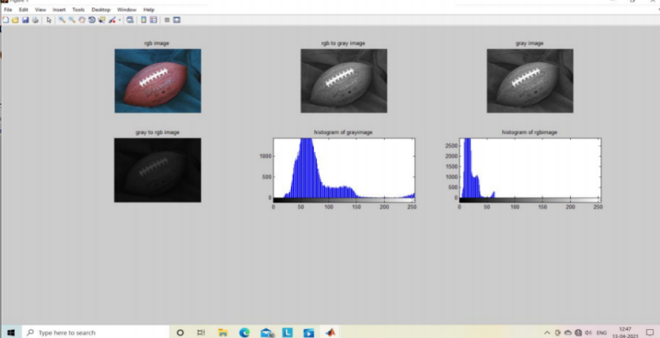

**FIG : conversion of rgb to grey image, histogram of grayimage and rgb image .**

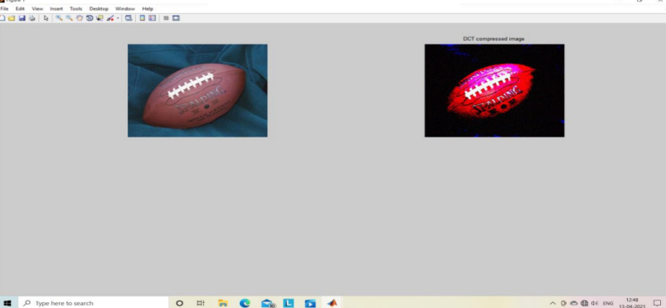

**FIG : DCT compressed image**

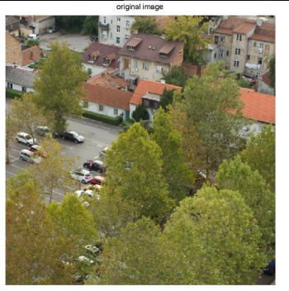 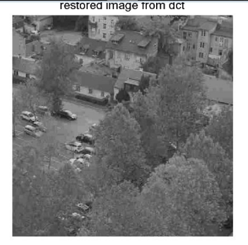

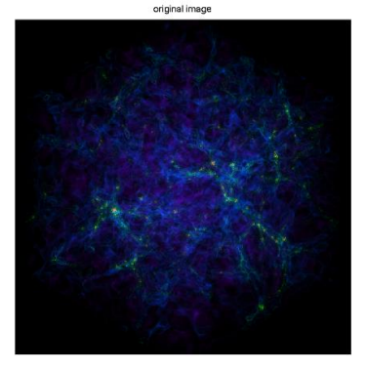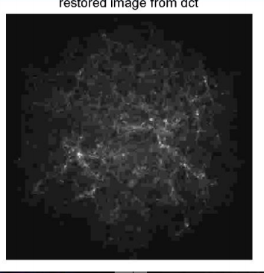

**CONCLUSIONS :** Thus, the JPEG image is converted into gray image and then into png image using MATLAB. The image compression also helps to save memory, as the size of the compressed image is less than the actual size of the image. In this project we have taken several images, in which original images are converted into compressed images using various compression methods. The JPEG image is compressed using MATLAB coding.Therefore reducing or removing redundant information makes the images compressed. For achieving the compression more effectively,the patterns in the data must be identified and utilized.

**REFERENCES :**

1. Kenta Kurihara, Shoko Imaizumi, Sayaka Shiota, and Hitoshi Kiya. An encryption-then-compression system for lossless image compression standards. IEICE transactions on information and systems, 100(1):52-56, 2017.

[2] T Hong LIU, Lin-pei ZHAIV, Ying GAO, Wen-ming LI``,Jiu-fei ZHOU``,``Image Compression Based on

Biorthogonaln Wavelet Transform”, IEEE Proceedings of ISCIT2005.

1. Wallace, G., The JPEG still picture compression standard, Communications of the ACM, 34 (1999 ) 31-44.
2. Digital Image Processing (Pearson Education, Second Edition) By Rafael C.Gonzalez and Richard E.Woods.
3. http://in.mathworks.com/matlabcentral/answers/152071-jpeg-compression-algorithm• implementation-in-matlab.

[5] Karam Lina J. Chapter 16 - Lossless Image Compression. In Al Bolvik, editor. The Essential Guide to

Image Processing, pages 385-419. Academic Press, Boston, 2009.

[6] 28. ‘Subhasis Saha, “Image compression- from DCT to Wavelets-AReview”

http://www.acm.org/crossroads/ xrds6-3/sahaimgcoding.html ‘

[7] ‘Raghuveer Rao & Ajit .S.Bopardikar “Wavelet Transforms-Introduction to theory &

applications”, Pearson Education Asia, New Delhi, 2004.’

[8] . ‘S.Srikanth and Sukadev Meher, Compression Efficiency for Combining Different

Embedded Image Compression Techniques with Huffman Encoding,IEEE, pp.

816-820, 2013. Malavar, H. S. Signal Processing with Lapped Transforms,

Norwood, MA, Artech House, 1992’